***Excel Assignment***

*Q: Use the attached “ExcelLabTwoStartingFile.xlsx” file to do the following instructions:*

1. Merge and Center the title “**Market Shares of Major Phone Providers in the United States**” in the range **A1:G1**
2. Change the title font to **Cambria 14 pt. Bold**
3. Merge and Center the sub-title “**Cellular Phones Sales During Five Years**” in the range**A2: G2**
4. Change the sub-title font to **Time New Roman, Bold**
5. **Bold** the range **A3:A13** and **B3:G3**
6. Apply **Total** style to the range **A10:F10**
7. Type **=B4+B5+B6+B7+B8** in cell **B10**, then press enter
8. Use the **AutoSum** function to calculate the total in cell **C10** for the range **C4:C8**
9. Use the **Fill Handle** to copy the function in cell **C10** to the range **D10:F10**
10. **AutoSum** the range **B4:F4** in cell **G4**
11. Use the **Fill Handle** to copy the function in cell **G4** to the range **G5:G8**
12. In cell **H4**, Apply 10% tax on the total sales if they are less than 2000000 and 40% else other. Use the **Fill Handle** to copy the function in cell **H4** to the range **H5:H8**
13. Apply the **Accounting** format to the range B4:G8
14. **AutoFit** the contents of each column (Do not display #######)
15. Remove the $ sign from the range B4:F8 and set the **Decimal Places** to 0
16. Use the Max function to display the **highest** value of the range **B4:B8** in cell **B11**
17. Use the Min function to display the **lowest** value of the range **B4:B8** in cell **B12**
18. Calculate the **average** of the range **B4:B8** in cell **B13**
19. Select the range **B11:B13** and use the **Fill Handle** to copy the functions in these cells to the range **C11:G13**
20. Delete **row 9**
21. Save and submit **ExcelLabTwo.xlsx** to my e-mail”ssa10@fayoum.edu.eg”

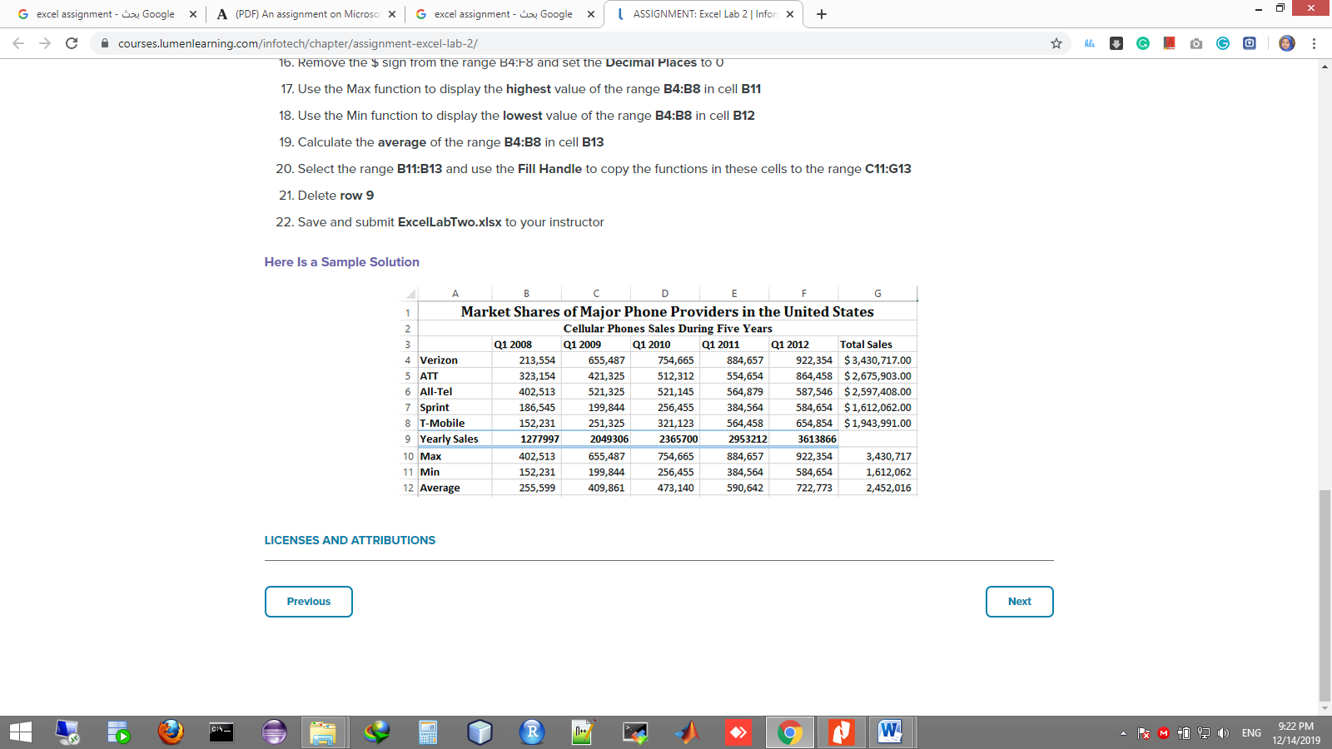***Sample output:***